Project Design Phase-II
Technology Stack (Architecture & Stack)

Date | 19 July 2026
Team ID
Project Name | Nightjar & Co. – MERN BookStore
Maximum Marks | 4 Marks

Technical Architecture
Description
Nightjar & Co. follows a three-tier architecture consisting of the Presentation Layer, Application Layer, and Database Layer. Users interact with the React frontend, which communicates with the Express.js and Node.js backend through REST APIs. The backend processes business logic, authenticates users using JWT, interacts with the MongoDB database through Mongoose, and returns JSON responses to the frontend.
Architecture Diagram
Nightjar & Co. – MERN BookStore is built using a three-tier architecture comprising the Presentation Layer, Application Layer, and Database Layer. This architecture separates the user interface, business logic, and data storage, making the application modular, maintainable, and scalable.
The Presentation Layer is developed using React.js (Vite) and provides an interactive and responsive interface where users can register, log in, browse books, search and filter the catalog, view book details, and manage their shopping cart.
The Application Layer is implemented using Node.js and Express.js, which expose RESTful APIs to process user requests, handle authentication using JWT, manage business logic, and communicate with the database.
The Database Layer uses MongoDB with Mongoose to store and manage user accounts, book information, and other application data. The backend retrieves and updates this data as required and returns JSON responses to the frontend.
This architecture ensures efficient communication between components, improves code organization, and provides a strong foundation for future enhancements such as online payments, order management, and cloud deployment.

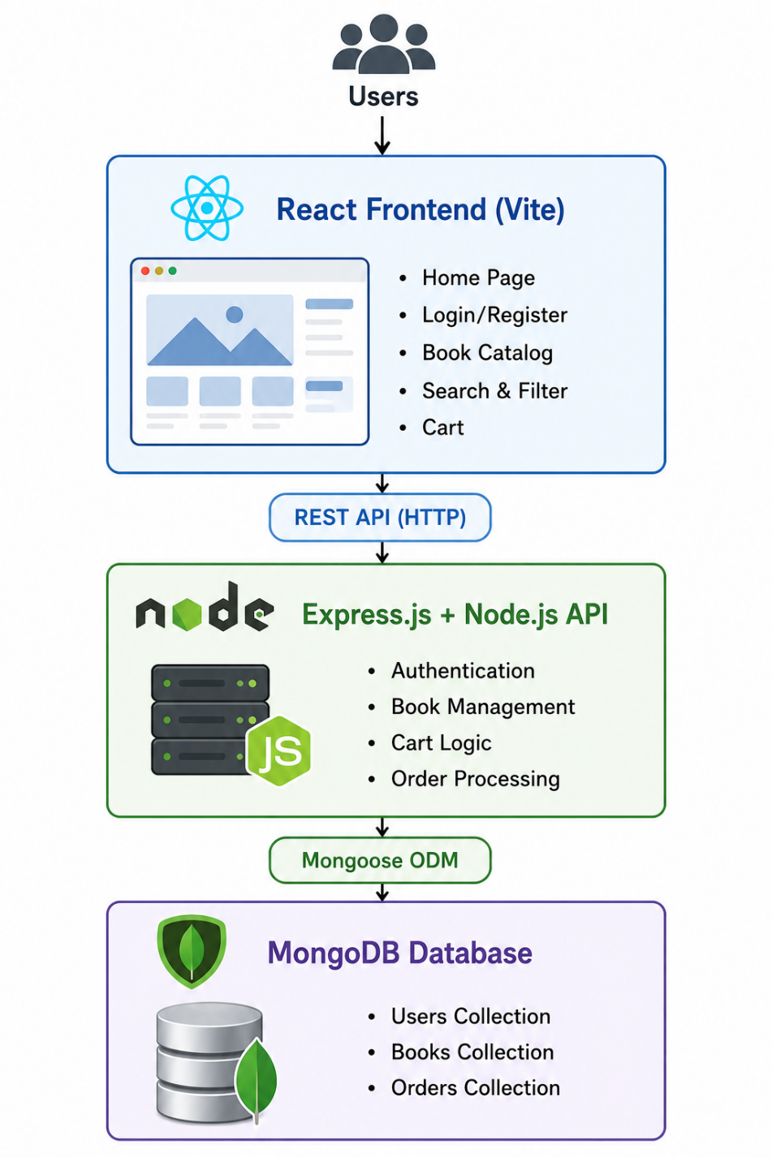
Table 1: Components & Technologies
S.No. | Component | Description | Technology
1 | User Interface | Web application for browsing books, login, cart, and orders | React.js (Vite), HTML5, CSS3, JavaScript
2 | Application Logic – 1 | Frontend routing and UI management | React Router, Context API
3 | Application Logic – 2 | Backend business logic and REST APIs | Node.js, Express.js
4 | Application Logic – 3 | Authentication and authorization | JWT, bcrypt.js
5 | Database | Stores users, books, and order information | MongoDB with Mongoose
6 | Cloud Database | Not implemented (can be extended to MongoDB Atlas) | MongoDB Atlas (Future Enhancement)
7 | File Storage | Stores static assets and uploaded images | Local File System
8 | External API – 1 | No external APIs used in the current version | —
9 | External API – 2 | Not applicable | —
10 | Machine Learning Model | Not implemented | —
11 | Infrastructure | Local development server | Node.js Local Server

Table 2: Application Characteristics
S.No. | Characteristic | Description | Technology
1 | Open-Source Frameworks | Frontend and backend developed using open-source frameworks | React.js, Node.js, Express.js, MongoDB, Mongoose
2 | Security Implementations | Password hashing, JWT authentication, protected API routes | bcrypt.js, JWT
3 | Scalable Architecture | Modular three-tier architecture with separation of frontend, backend, and database | MERN Stack, REST APIs
4 | Availability | Accessible through modern web browsers whenever the backend server is running | Node.js Server, HTTP
5 | Performance | Efficient API communication, lightweight JSON responses, optimized MongoDB queries | REST API, MongoDB, Mongoose

